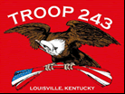
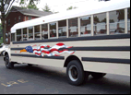
TROOP 243
October 1st, 2010
Boy Scouts of America
Chartered by St. Barnabas Catholic Church

3044 Hikes Lane Louisville, Ky 40220
http://www.troop243.com

Dear Parents and Friends of Troop 243,

Troop 243 Outings & Activities – October is a pretty busy and fun month, but aren’t they all! We start out the month with a 15-mile bike ride and later a 25-mile ride toward earning the cycling merit badge. Our troop’s leadership training is also at the beginning of the month. Next comes the annual first class banquet at the Crooked Creak dining hall with this year’s speaker, Pat Day. The very next day we take off for the Multi-Council Centennial Jamboree at EP Sawyer Park. Throughout the month our troop meetings will focus on shooting sports. Lastly, Crew 243 will be staffing the Centennial celebration as well as this month’s Wood Badge training.

Troop and Patrol Meetings on Wednesdays - All are welcome. Scouts in Class A uniforms are expected. Except where noted, all meetings are held at St. Barnabas.
October 6, 7:00 PM – Troop Meeting – Shooting Sports
October 13, 7:00 PM – Patrol Meetings
October 20, 7:00 PM – Troop Meeting – Shooting Sports
October 27, 7:00 PM – Troop Meeting - Shooting Sports

Cycling Merit Badge – We are going to be doing several things to help the boys earn the Cycling merit badge. We will do a 15-mile ride on October 9th at the Cherokee Park Daniel Boone Statue starting at 3:00 and a 25-mile ride on October 17th.

Junior Youth Leadership Training –Troop 243 will host a leadership training session on October 3rd from 2:00 – 6:00. We preferred that every scout have this training prior to taking on a leadership position such as Patrol Leader or Senior Patrol Leader.

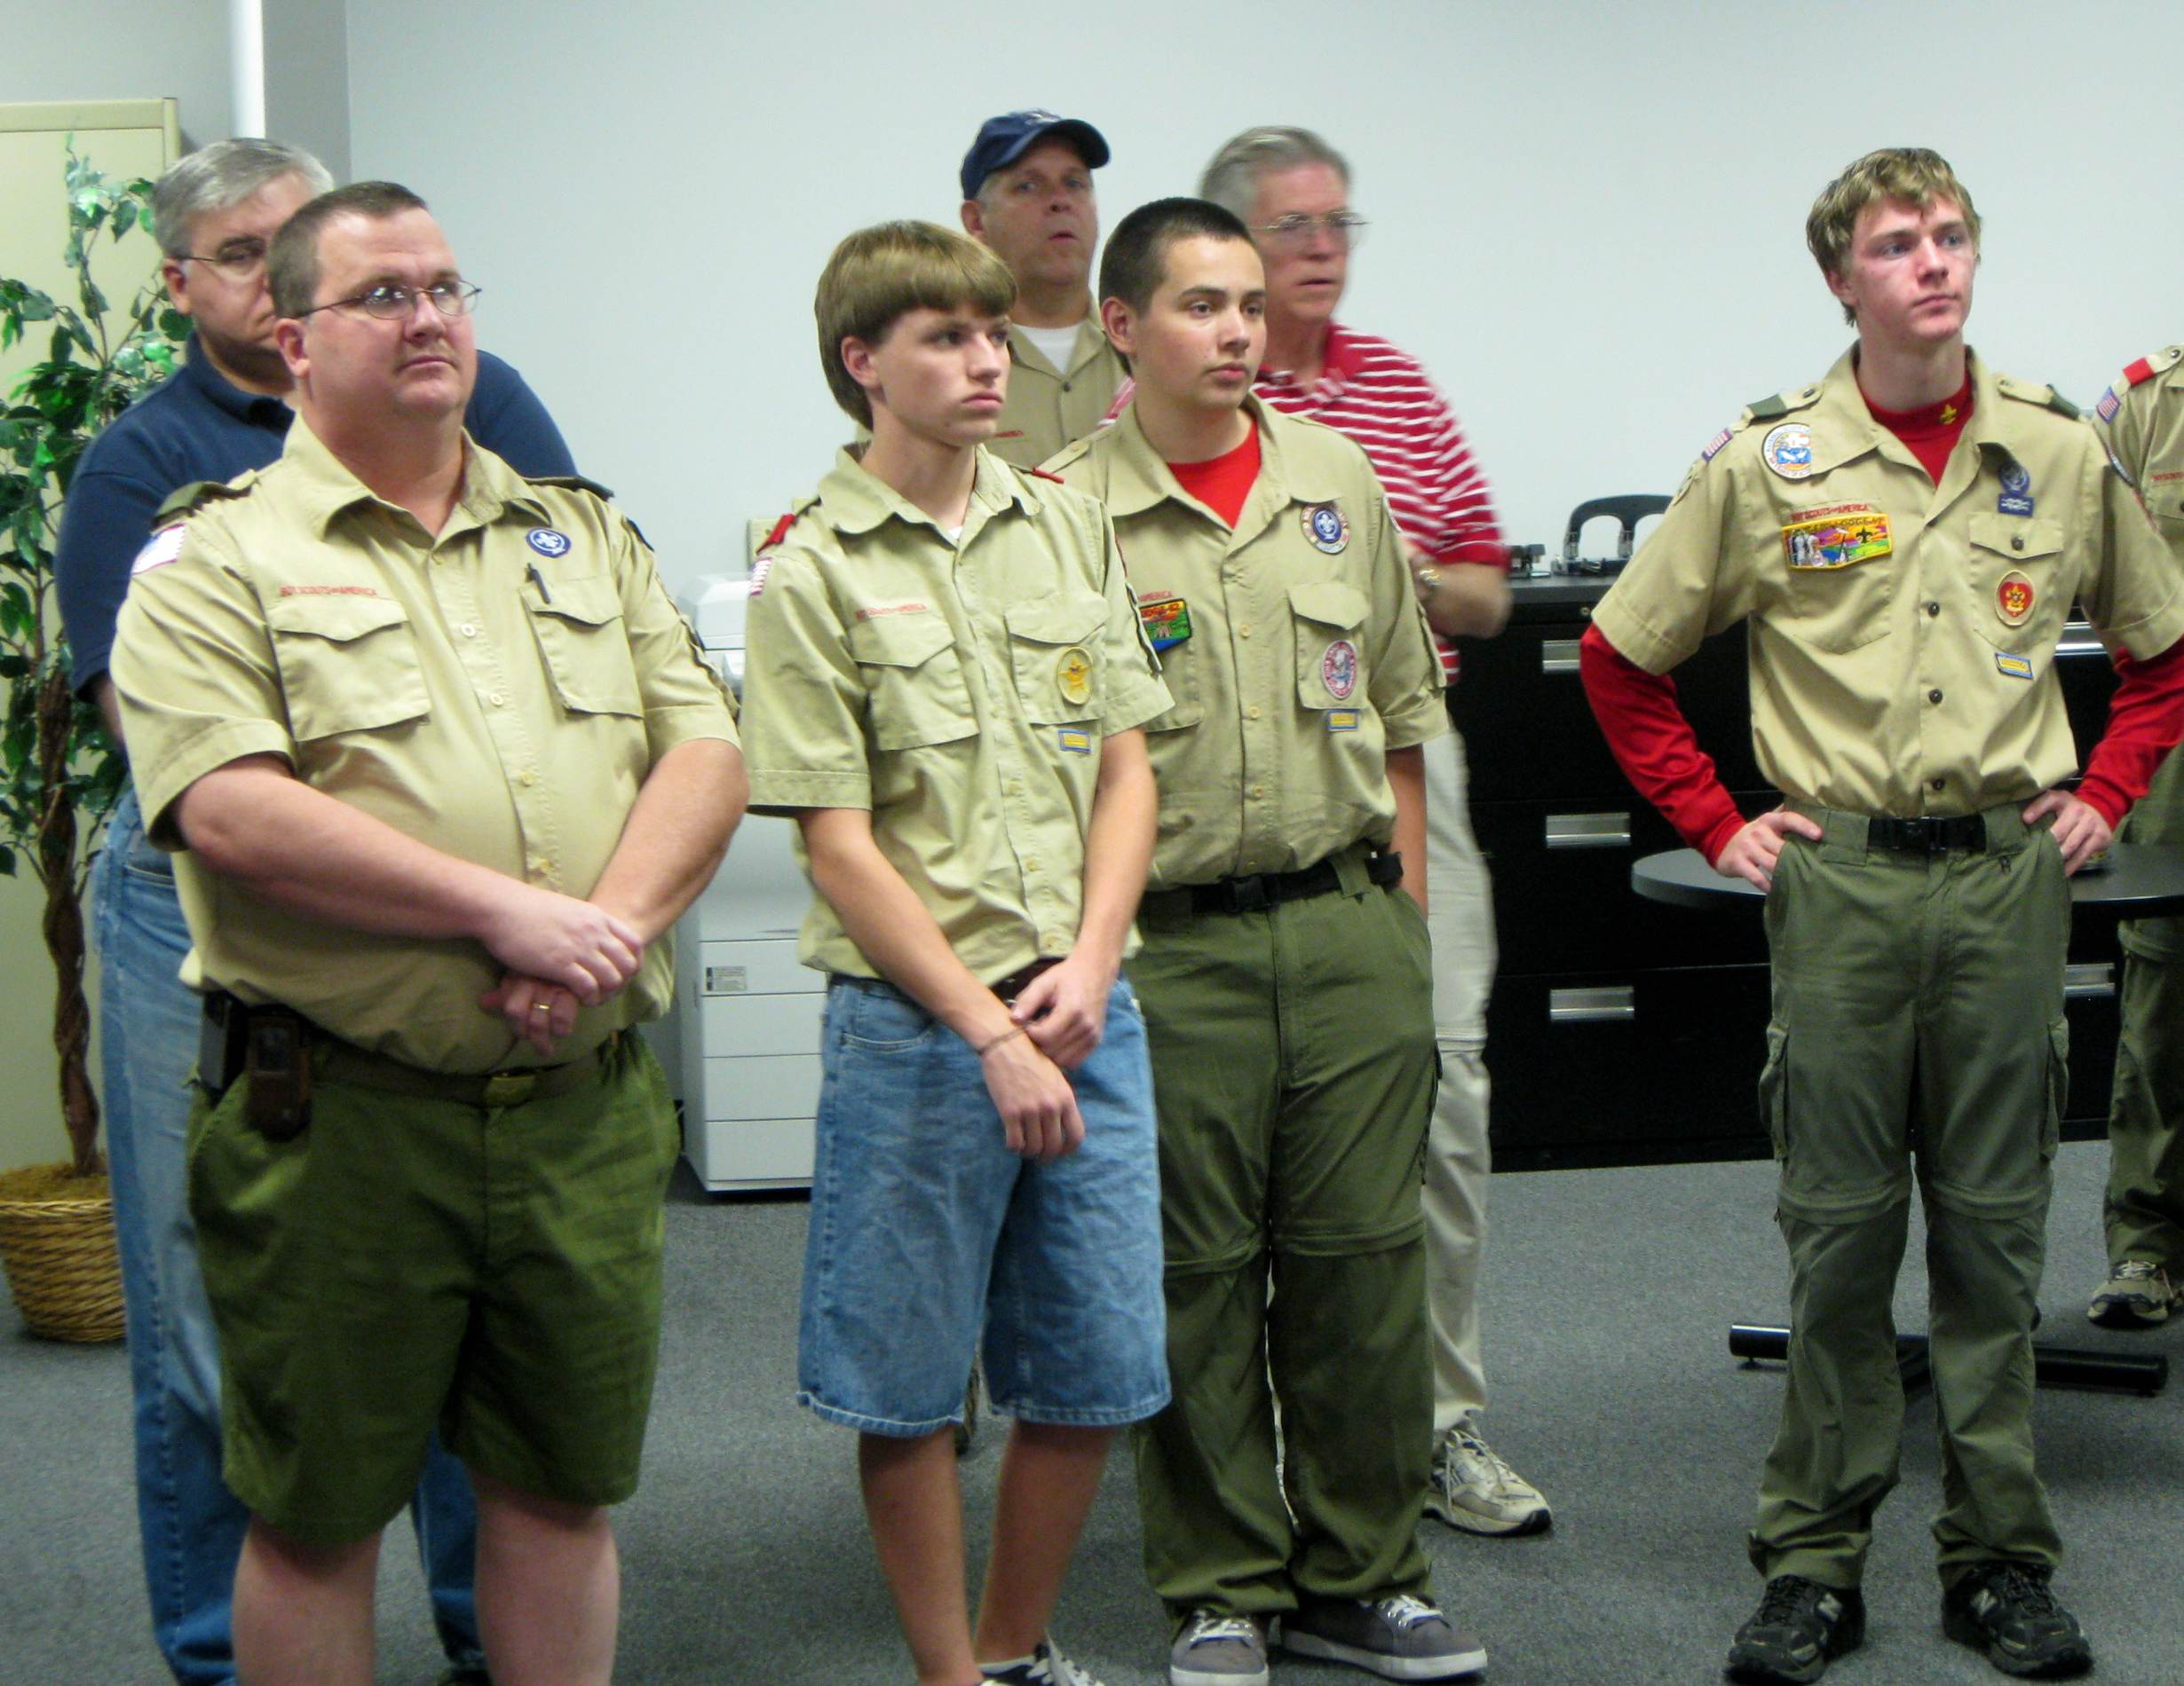
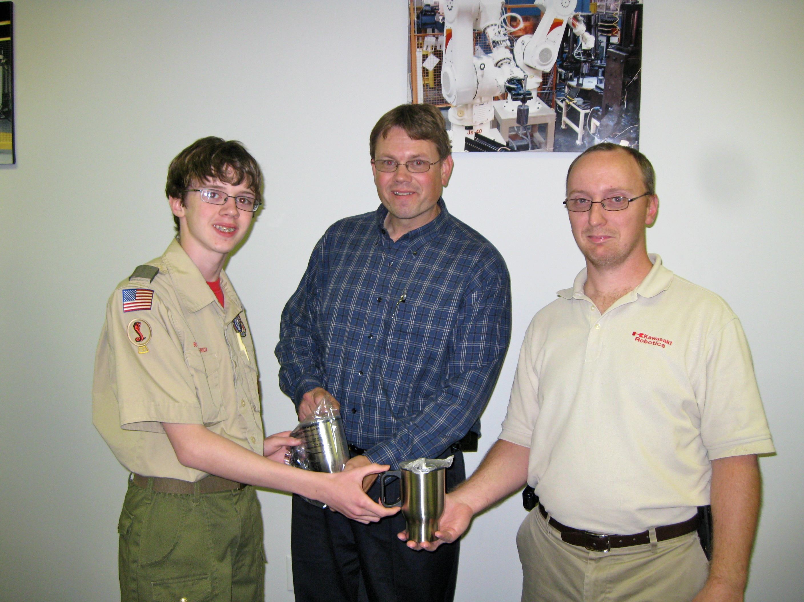
Kawasaki Robotics Tour – Our thanks go out to Tim Jansing for setting up a most excellent tour of the Kawasaki Robotics plant. Our boys got to see what real working robots look like and get an idea of what they can do. We learned about the left hand X,Y, Z axis idea that keeps the programs running and were shown an actual, relatively simple program that ran a robot.
Zach Yates, Sr. Patrol Leader, presents troop mugs to our hosts Mike Dillon & Jeff Randall
Above is a picture of a small portion of the 50 or so attendees for our Kawasaki Robotics tour.

Multi-Council Centennial Jamboree – We are participating in the Centennial Jamboree in October. We will leave for Sawyer park around 5:45 Friday, October 15 (time approximate) and return in time to offload and attend 11:00 Mass at St. Barnabas. This year Cub Scouts from Pack 756 will ride the bus with us and camp adjacent or near by but they will be on their own for food. Crew 243 will be working the event. This promises to be a unique, fun and popular event for the whole family.

Troop Leadership meetings – While the September leadership meetings are being held at the beginning of October, the October PLC meeting will be held on Sunday October 24th at 4:00. The adult meetings are scheduled for 7:00 and 8:00 on Monday October 25th. All boys are invited to participate in the PLC and all adults are invited to join us for the adult leadership meetings.

Troop Gift Cards – Transportation to the vast majority of our outings is free to our scouts and leadership, but it is not free. The cost of maintenance, fuel and insurance for our bus is paid by the Friends of Troop 243. Friends of Troop 243 is funded by the Kroger and Thorntons gift card programs. We encourage all parents, members, relatives and friends to use Troop 243’s Kroger and Thorntons gift cards. Whenever you see Frank Hulsman at any function please stop him and ask him for one or both of these cards and he will be glad to give you one.

Yours in Scouting,
Bruce Bohn
Pictured above is the recipient of the Mark Zimmerer Award, Joseph Wuertz. In the picture from L to R are Frank Hulsman, Jerry Zimmerer, Joseph, Regina Zimmerer and Linda Wuertz.
Troop Secretary

